Exp 5 :

Creating a virtual machine using public cloud services in Microsoft Azure.

Step 1:

Click on resource group.

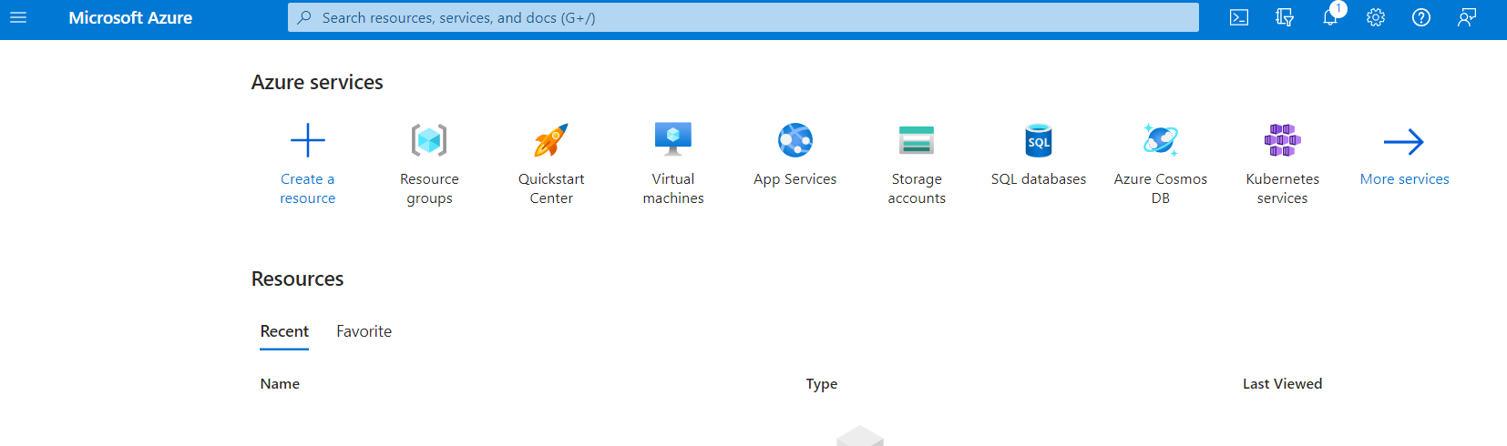

Step 2:

click on create.

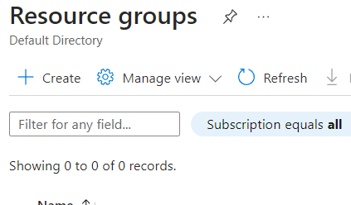

Step 3:

Enter resource group as “record”.

Select region accordingly.

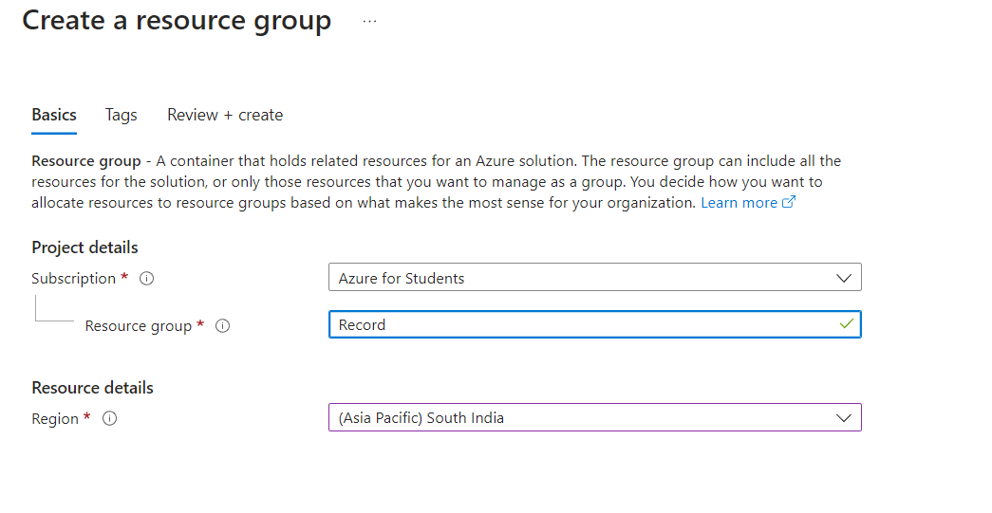

Click on Next:Tags > .

Step 4:

Click on Next: review + create > .

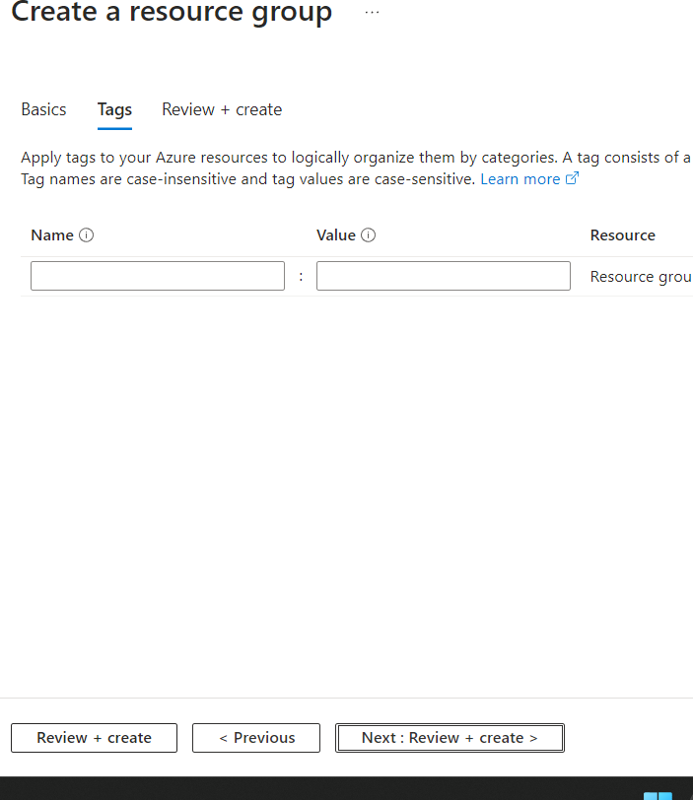

Step 5 :

Click on Create .

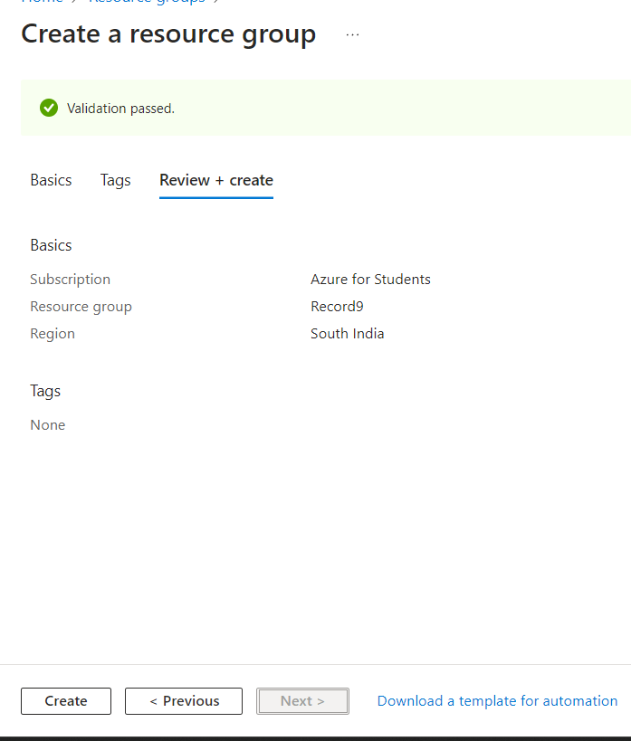

Resource group is created successfully.

